Links to Movies – supplemental materials for

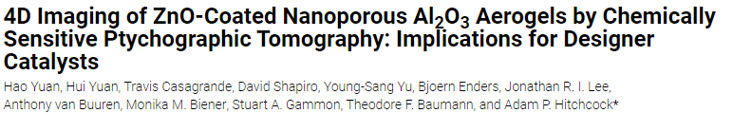

Hao Yuan, Hui Yuan, Travis Casagrande, David Shapiro, Young-Sang Yu, Björn Enders, Jonathan R. I. Lee, Tony Van Buuren, Monika M. Biener, Stuart A. Gammon, Tian T. Li, Theodore F. Baumann and Adam P. Hitchcock, 4D Imaging of ZnO-Coated Nanoporous Al₂O₃ Aerogels by Chemically-Sensitive Ptychographic Tomography: Implications for Designer Catalysts, ACS Applied Nanomaterials 4 (2021) 621-63. doi:10.1021/acsanm.0c02924

Full cylinder
https://pubs.acs.org/doi/suppl/10.1021/acsanm.0c02924/suppl_file/an0c02924_si_002.mp4

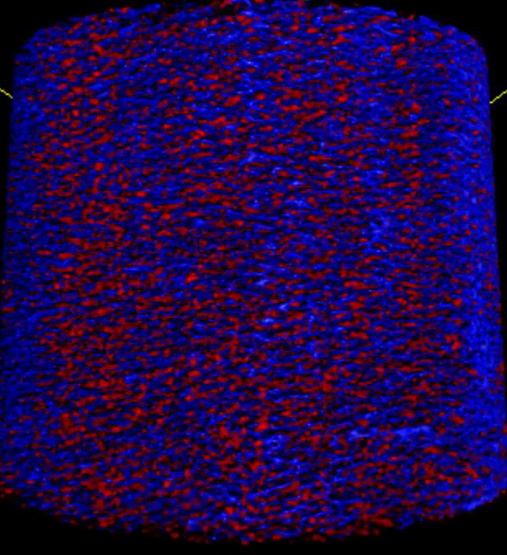
Fly Through

https://pubs.acs.org/doi/suppl/10.1021/acsanm.0c02924/suppl_file/an0c02924_si_003.mp4

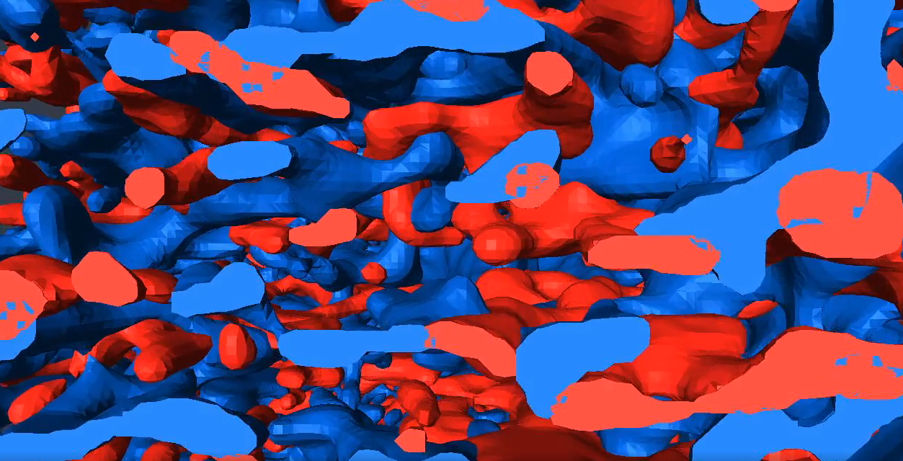

POROSITY MAP
https://pubs.acs.org/doi/suppl/10.1021/acsanm.0c02924/suppl_file/an0c02924_si_004.mp4

